Assignment 2

Title:

|  |
| --- |
| Write a program to implement Parallel Bubble Sort and Merge sort using OpenMP. Use existing algorithms and measure the performance of sequential and parallel algorithms. |

**Outcome:** At the end of this session student will be able to:

1) Understand OPENMP thread model.

2) Parallelisation of for loop using OPENMP pragma instruction.

3) Able to write the code using OpenMP and paste it for result.

Theory:

Bubble sort

The sequential version of the bubble sort algorithm is considered to be the most inefficient sorting method in common usage.

OpenMP expose an application’s task and loop level parallelism in an incremental fashion.

OpenMP is the implementation of multithreading, a parallel execution scheme where the master thread assigns a specific number of threads to the slave threads and a task is divided between them.

OpenMP is basically designed for shared memory multiprocessors, using the SPMD model (Single Program, Multiple Data Stream). All the processors are able to directly access all the memory in the machine, through a logical direct connection. Programs will be executed on one or more processors that share some or all of the available memory. The program is typically executed by multiple independent threads that share data, but may also have some additional private memory zones.

OpenMP provides a straightforward interface to write software that can be used for multiple core computers. Using OpenMP the programmer can write code that will be able to use all cores of a multicore computer, and will be run faster if the number of cores are increased.

environment to be able to understand OpenMP statements. It is not worthwhile just to write #include < opm.h>header.

OMP programming model:

OpenMP is an application programming interface that supportes shared memery multiprocessing progrmming in C,C++ and other platform. OpenMP uses portable simple& flexible interface for developing parallel application for platform ranging from desktop computer to super computer.

Thread Modes:

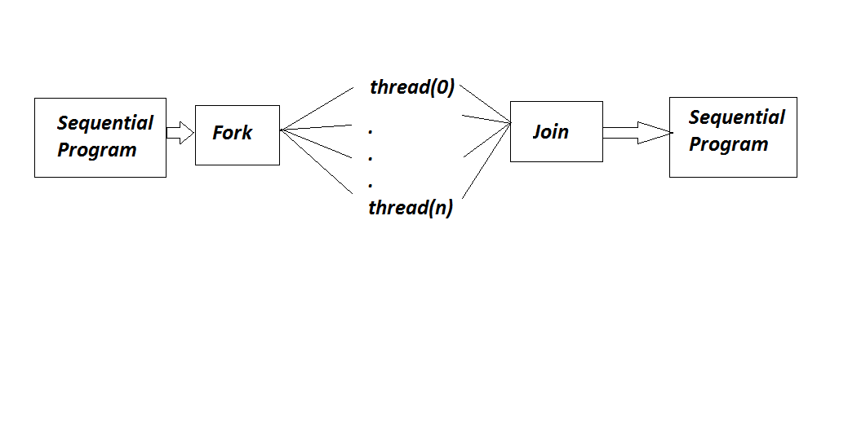

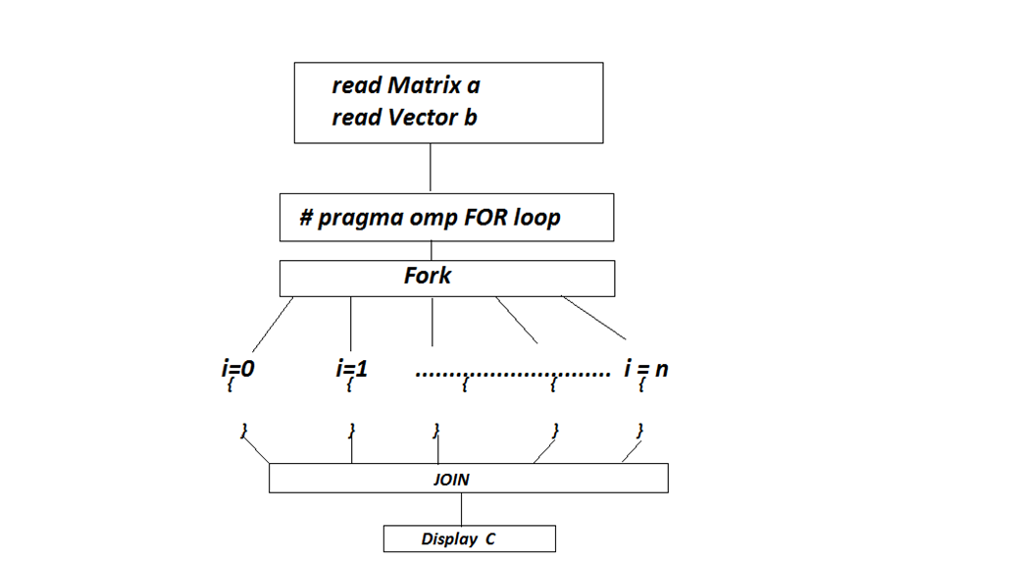

**Procedure:**

1) Developed & install CodeBlock/Colab compiler which has inbuilt OpenMP library.

2) Write a program in Text editor & save it as .c extension.

3) In OPENMP header file used is<openmp.h>

4) Built & run program.

5) Verify the result.

**Conclusion:**

Parallel operation of bubble sort is implemented using OMP compiler. Performance of sequential and parallel model is compared.